In jquery before selecting the elements from the document initially we need to makes sure the document is completely ready

Jquey alias we use fir any selection or using jquery feature is $

Code to check if the document is ready is

$(document).ready( function()

{

//code inside the function

});

In the above code we select entire document object which Is a root for all the elements present inside the HTML document.

And check if the document is ready

Execute the mentioned function only if the given document Is ready.

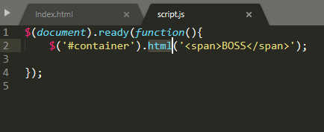

$(“#id”) id selector to select the element based on the id

$(“.class1, .class2”) class selector used to select the item based on the class and comma can be used to select multiple items.

Jquery is case sensitive so use right case while writing the code

Most of the methods are camel case.

**Selecting descendants:**

All descendants

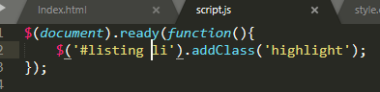

Direct decedents:

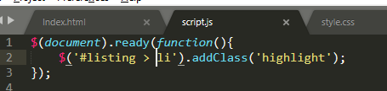

Attribute selector:

Used to select the element in the document based on the control attribute values.

Direct selection

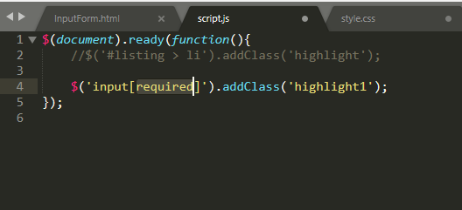

Attribute value selection

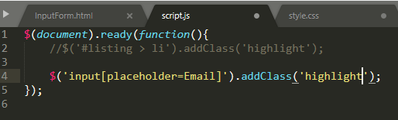

Wild card selection

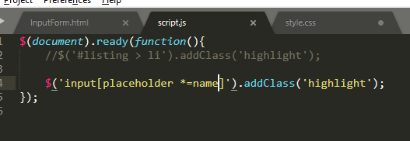

Traversing the DOM:

Traversing through the node list until find the required element. Finding decedents using the traversing techniques.

Find(): returns all decedents matching the patterns

Method to find all the decedents matched with the specified target selector:

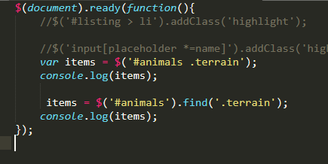

Children():

Method works similar to find but this will return only the matching element that are direct children of the specified element.

Traversing result into many result there are helper method using which I can iterate over the result from the traversing.

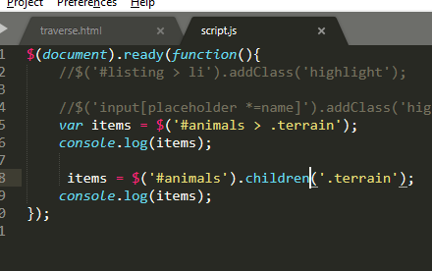

Say if nothing is specified inside the children then the selector will return all the children of the selected parent control.

Other helper methods:

First(): Got to the first element from the list of nodes returned

Last(): last node element from the list of node elements

Next(): read next node from the current selected node

prev(); read previous node from the currently selected node

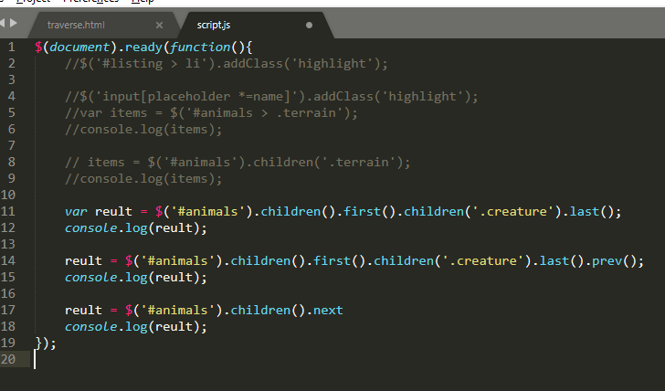

Traversing to parent:

Parent(); returns the immediate parent

Parents(); return all he parents in the hierarchy till it reaches top parent element (if nothing specified for matching)

Closest(); returns the closest container matched the specified match.

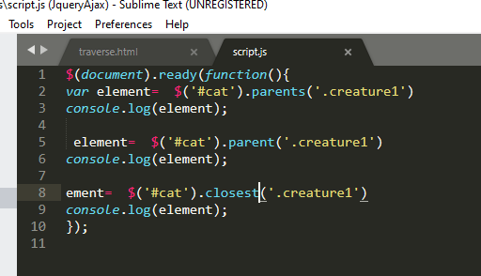

Events: click()

We need to add event listener for the event fired in a web page.

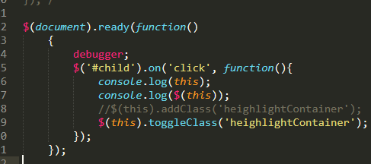

Event delegation:

We use container element to set the event handler for the control that is define d inside the container

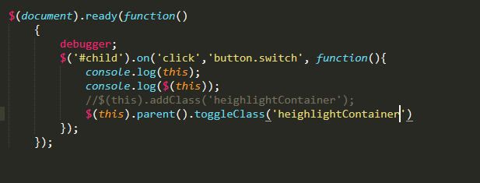

Event listener for select control.

First using container or id find the control

var selected = $('#place option:selected');

then select value using val() method

Then select data using attr(‘attribute’) or data(‘sufix’ ) suffix of the attribute.

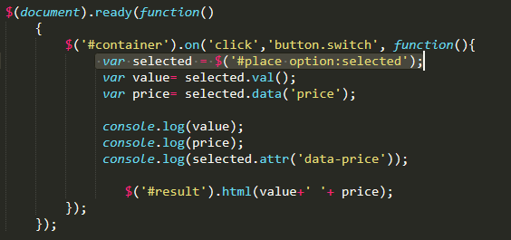

Change event:

Selected value changed scenario

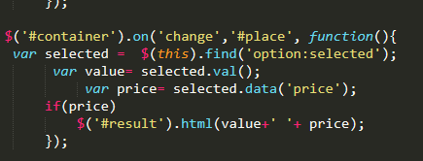

Key events:

Basically, used to control the keyboard events.

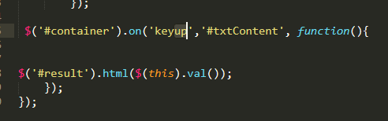

Preventing the default behaviour of the event:

Eg: click on to anchor tag it will redirect you to the target mentioned in the href tag.

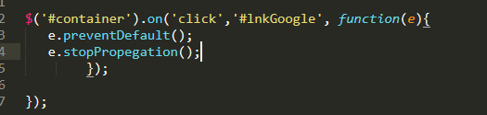

Code give as above

We are blocking the default behaviour of the click event

So for the function we need to pass current event object

Old way is return zero from the method

Dom manipulation:

Adding Html element to the page programmatically

We use

1. Append (end of the selected container)
2. Prepend (beginning of the selected container)
3. AppendTo (Html makes selection of container)
4. PrependTo (Html object makes selection of the container)

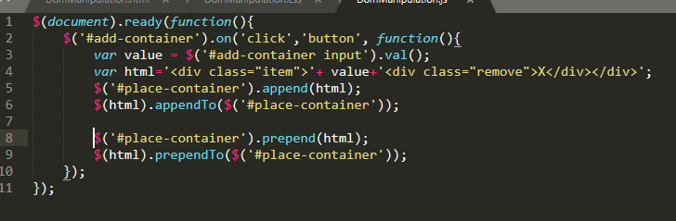

Say I want to insert the element before or after the container or selected item

After() : append item after the element

Before(): append item before the element

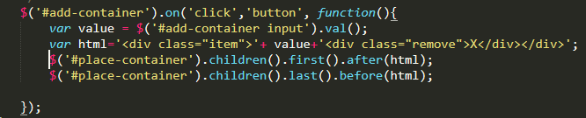

Remove element.

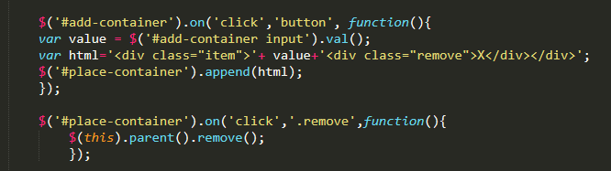

We can even programmatically add attribute to the Html element or even remove the content from html element

Empty()

.attr(“”,””); key value pair

To read attribute value .attr(“key”);

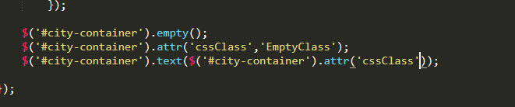

**Animation effect:**

Hiding and showing element

On click of any element initially prevent the default behaviour then find the element from the right hierarchy

**Apply animation effect.**

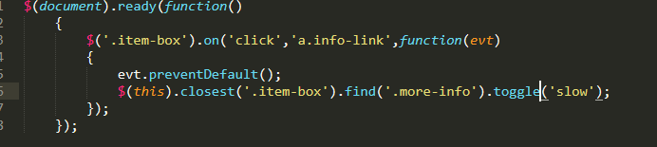

.show()

.hide()

.toggle()

**Fading effect:**

.fadeIn()

.fadeOut()

.fadeToggle()

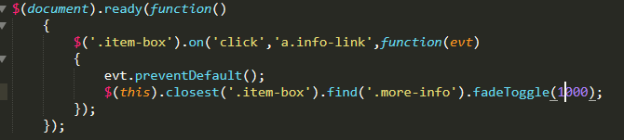

**Sliding effects:**

slidUp();

slidDown();

slidToggle();

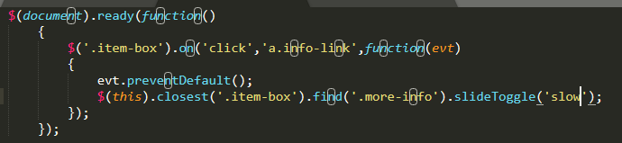

Animation in HTML control:

Using animation method of the element

Eg: animate({css},delay,function(){ method to execute on completion}

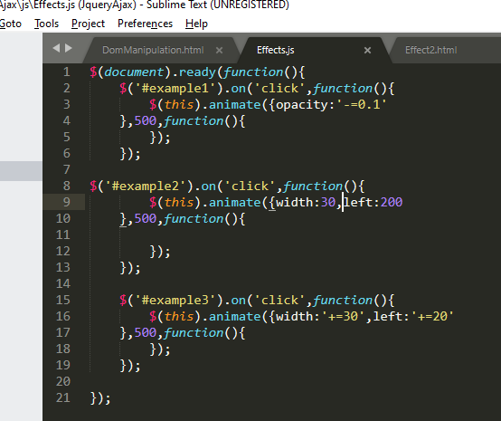)

Ajax jquery:

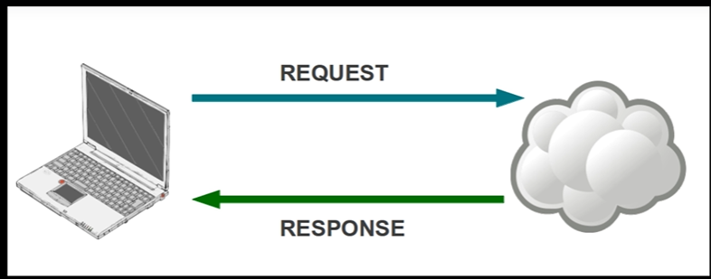

Asynchronously load the data from the server

Asynchronous JavaScript and XML

Load page content using ajax call

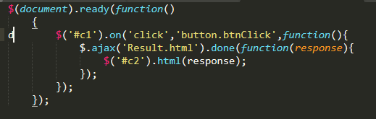

Executing methods before and after ajax call:

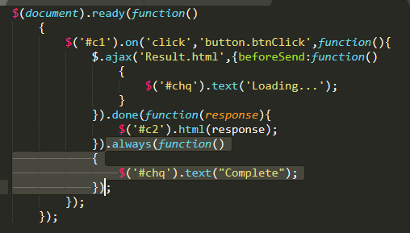

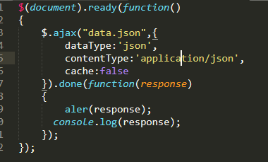

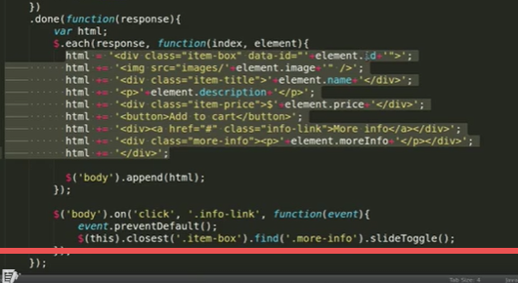

Post request from the jquery:

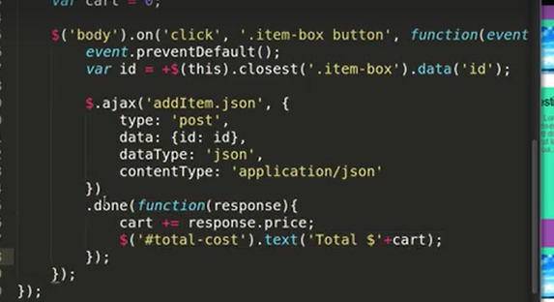

Form fields in ajax:

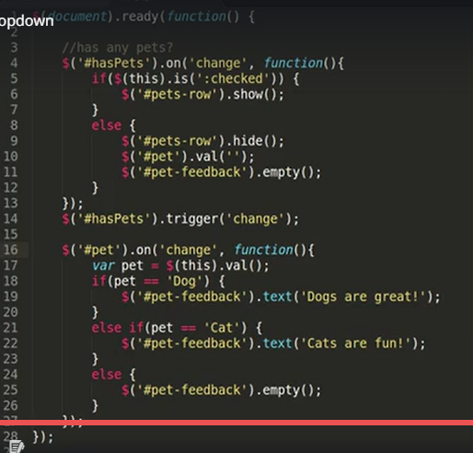

Form:

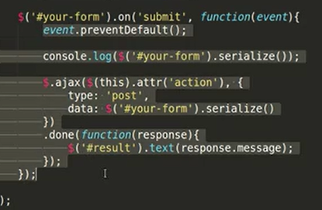

jQuery selector:

1. $("*") selected every element from the document.
2. $("#lastname") select element with the specified id
3. $(".intro") select item with the mentioned class.
4. $(".intro,.demo") select all the items with the class listed in the comma separated value.
5. $("p") element selector selects all element with this tag
6. $("h1,div,p") multi element selector
7. $("p:first") in combination with any of the root selector it will match first element form the match
8. $("p:last") in combination with any of the root selector it will match first element form the match
9. $("tr:even") in combination with selector selects elements in even position
10. $("tr:odd")") in combination with selector selects elements in even position
11. $("p:first-child") select p if it is a first chid of its parent (considering all the type of element)
12. $("p:first-of-type") : All p elements that are first p element of the parent
13. $("p:last-child") select p if it is a last chid of its parent (considering all the type of element)
14. $("p:last-of-type") p elements that are last p element of the parent
15. $("p:nth-child(2)"): selects p where p is a nth first child of the parent
16. $("p:nth-last-child(2)") selects all p where p is nth child of its parent
17. $("p:nth-of-type(2)") selects p where p is nth last child of parent.
18. $("p:nth-last-of-type(2)") select all p where p is last nth child of its parent
19. $("p:only-child"): p is a only child or single child of the parent
20. $("p:only-of-type") all p where p is the only child of type p to its parent
21. $("div > p"): selects p if it is a immediate child of dv
22. $("div p") all which are child of p
23. $("div + p") p element which is net to div
24. $("div ~ p") sibling of div all p which are at same level

|  |  |  |
| --- | --- | --- |
| [:input](https://www.w3schools.com/jquery/sel_input.asp) | $(":input") | All input elements |
| [:text](https://www.w3schools.com/jquery/sel_input_text.asp) | $(":text") | All input elements with type="text" |
| [:password](https://www.w3schools.com/jquery/sel_input_password.asp) | $(":password") | All input elements with type="password" |
| [:radio](https://www.w3schools.com/jquery/sel_input_radio.asp) | $(":radio") | All input elements with type="radio" |
| [:checkbox](https://www.w3schools.com/jquery/sel_input_checkbox.asp) | $(":checkbox") | All input elements with type="checkbox" |
| [:submit](https://www.w3schools.com/jquery/sel_input_submit.asp) | $(":submit") | All input elements with type="submit" |
| [:reset](https://www.w3schools.com/jquery/sel_input_reset.asp) | $(":reset") | All input elements with type="reset" |
| [:button](https://www.w3schools.com/jquery/sel_input_button.asp) | $(":button") | All input elements with type="button" |
| [:image](https://www.w3schools.com/jquery/sel_input_image.asp) | $(":image") | All input elements with type="image" |
| [:file](https://www.w3schools.com/jquery/sel_input_file.asp) | $(":file") | All input elements with type="file" |
| [:enabled](https://www.w3schools.com/jquery/sel_input_enabled.asp) | $(":enabled") | All enabled input elements |
| [:disabled](https://www.w3schools.com/jquery/sel_input_disabled.asp) | $(":disabled") | All disabled input elements |
| [:selected](https://www.w3schools.com/jquery/sel_input_selected.asp) | $(":selected") | All selected input elements |
| [:checked](https://www.w3schools.com/jquery/sel_input_checked.asp) | $(":checked") | All checked input elements |

|  |  |  |
| --- | --- | --- |
| [[*attribute*]](https://www.w3schools.com/jquery/sel_attribute.asp) | $("[href]") | All elements with a href attribute |
| [[*attribute*=*value*]](https://www.w3schools.com/jquery/sel_attribute_equal_value.asp) | $("[href='default.htm']") | All elements with a href attribute value equal to "default.htm" |
| [[*attribute*!=*value*]](https://www.w3schools.com/jquery/sel_attribute_notequal_value.asp) | $("[href!='default.htm']") | All elements with a href attribute value not equal to "default.htm" |
| [[*attribute*$=*value*]](https://www.w3schools.com/jquery/sel_attribute_end_value.asp) | $("[href$='.jpg']") | All elements with a href attribute value ending with ".jpg" |
| [[*attribute*|=*value*]](https://www.w3schools.com/jquery/sel_attribute_prefix_value.asp) | $("[title|='Tomorrow']") | All elements with a title attribute value equal to 'Tomorrow', or starting with 'Tomorrow' followed by a hyphen |
| [[*attribute*^=*value*]](https://www.w3schools.com/jquery/sel_attribute_beginning_value.asp) | $("[title^='Tom']") | All elements with a title attribute value starting with "Tom" |
| [[*attribute*~=*value*]](https://www.w3schools.com/jquery/sel_attribute_contains_value.asp) | $("[title~='hello']") | All elements with a title attribute value containing the specific word "hello" |
| [[*attribute\**=*value*]](https://www.w3schools.com/jquery/sel_attribute_contains_string_value.asp) | $("[title*='hello']") | All elements with a title attribute value containing the word "hello" |

Reusable javascript library: derived from javascript sits on top of javascript to make javascript coding easy

Javascript is language

Jquery is library

Every jquery command follows

SSS format: Start with $ -> Select element -> Shoot command

CDN CDN fall back:

Content delivery network

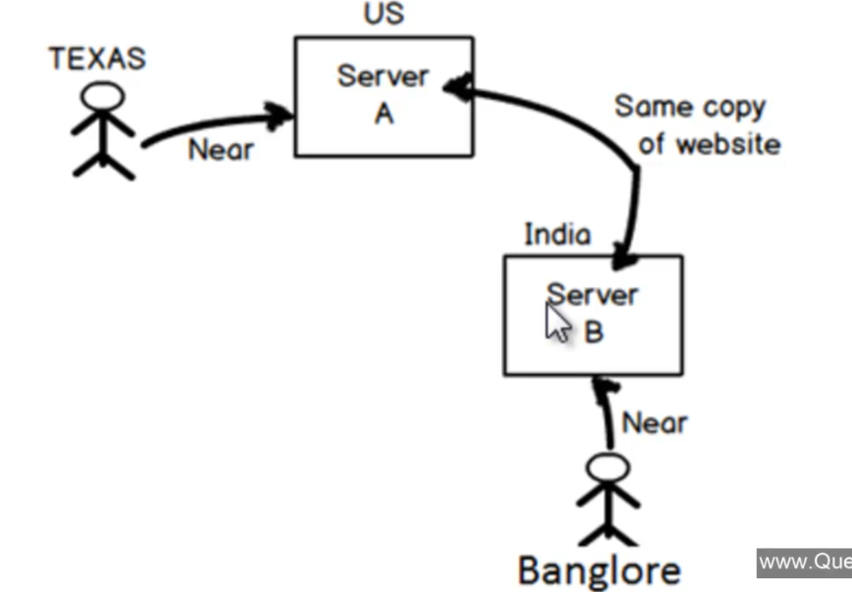

Same website content is copied to different geographical server. So based on the user location content will be given from the nearest geographical server.

Lead to quick delivery of the data reduces the bandwidth and less load on the server

Say I’m using jquery in my application and files are copied in my server when the lot of users logs into my system and request for jquery it will have some impact on my server

Two cdn for jquery

Google and Microsoft

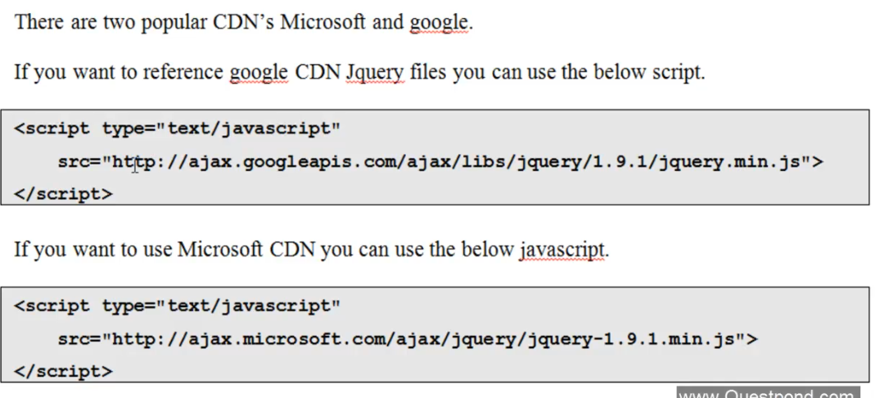

Process in which we specify by any chance if the cdn goes down use local resources.

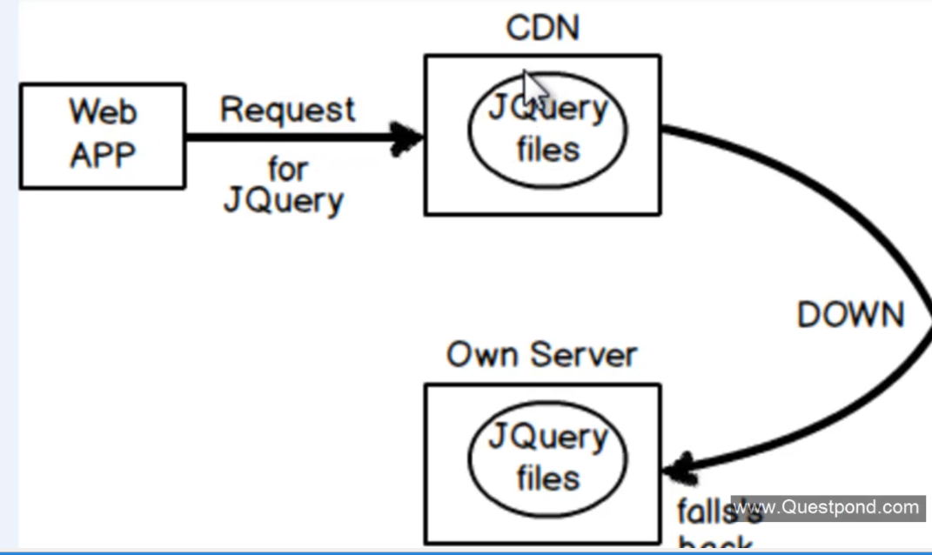

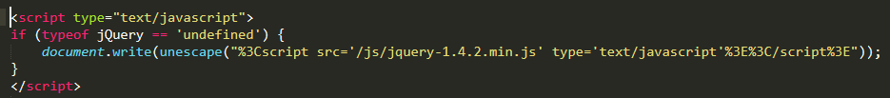

Any jquery logic put above the control before the control rendering wont work so need to put tha logic always down .

$(document).ready();

Makes sure that script is executed only after the complete load of the dom

7 important selector

Jason:

Javascript object notation

Format used to exchange the data between the client and server side technology.

Object enclosed within curly bracket {}

And key value pairs separated by :

And each property pair is separated with comma ,

